

**Satellite Imagery**

assisting in

**Crop yield Prediction**



Humans have a fair understanding of the greenness,moisture,vegetation area and some other related factors when looking at a satellite image and can to a basic level differentiate between two areas in terms of potential for vegetation growth and its sustainability.

**Vegetation Indices** are dimensionless indices calculated from satellite images which help us in various ways to get a better idea of this.

Vegetation Indices

In our project to understand the importance and achieve better results we have shortlisted and made use of the following indices:-

● NDVI

● EVI

● ARVI

● GCI

● NDWI

NDVI

The following are the satellite images of 2 places:-

The Amazon Rainforest, and The Sahara Desert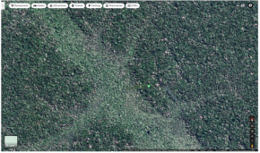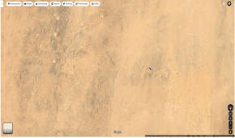

NDVI

NDVI (normalized difference vegetation index) is one such index which helps in understanding greenness where the higher value indicates more greenness(high vegetation areas,healthy plants) and lower indicates barren areas(and withering plants).

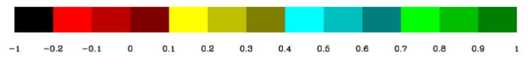

NDVI

It is calculated by

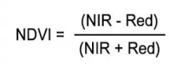

Thus we find NDVI for each coordinate and train the model with the indices and draw comparisons

EVI

**EVI(Enhanced Vegetation Index)** is an optimized vegetation index which works like NDVI providing greenness measure but also provides some correction for noise and atmospheric conditions with better results in areas of high density of vegetation.

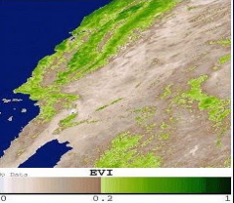

EVI

EVI is calculated by

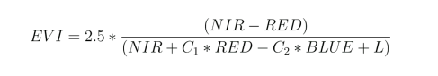

Where

C1(=6) is the red correction factor

C2(=7.5) is the blue correction factor L(=1) is the canopy background correction factor

Key Features:-

● Corrected NDVI

● Accounts for noise and atmospheric conditions ● Better results in high density vegetation areas

ARVI

ARVI(Atmospherically Resistant Vegetation Index) is a more refined form of NDVI which amounts for atmospheric correction due to pollutants(aerosol like soot,fog etc).It also provides better results as it takes into account the topology / terrain of the region .This makes it more effective for mountainous regions . 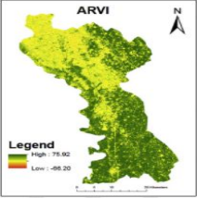

ARVI

ARVI is calculated by

ARVI = Key Features:-

● Corrected NDVI

● Accounts for pollutants in air

● To some extent accounts for terrain/topology

GCI

GCI (Green Chlorophyll Index) is the measure of the chlorophyll in leaves.This states the health of the plant / crop and can thus be good for measuring yield.

Since it deals directly with the chlorophyll content it can be used in comparing yield before and after using pesticides , accounting for environmental stress on plants ,etc.

GCI

GCI is calculated by

GCI = 

Key Features:-

● Chlorophyll content detection

● Useful for accounting for pesticide/chemical effect on plants ● Can account for environmental stress

NDWI

NDWI(Normalized Difference Water Index) is an index which helps to determine the crop condition by accounting for moisture content in plants and crops.This proves helpful for drought prone areas and water stress in vegetation. 

NDWI

NDWI is calculated by

NDWI = 

Key Features:-

● Measures leaf moisture

● Can account for droughts and plant moisture requirements